 |  | Substation |  |  | JALAN ROBINSON |  |  |  |  |  |  |  |  |  |  |  |  | Date: 01/06/2026
 |  | Equipment |  |  | RMU SF6 |  | Manufacturer |  |  |  |  |  |  |  |  | TAMCO |  | Time: 4:02 PM
 |  | Model |  |  | GR1 |  | Rating |  |  |  |  |  |  |  |  | 12kV |  | Humidity: 77%
 |  | Area |  |  | CABLE COMPARTMENT |  |  |  |  |  |  |  |  |  |  | Panel No. |  | CCH00666
Panel Name |  | JALAN BOH
 | IR IMAGE |  |  |  |  |  |  |  |  |  |  | VISUAL IMAGE
 |  |  |  |  |  |  |  |  |  |  |  | 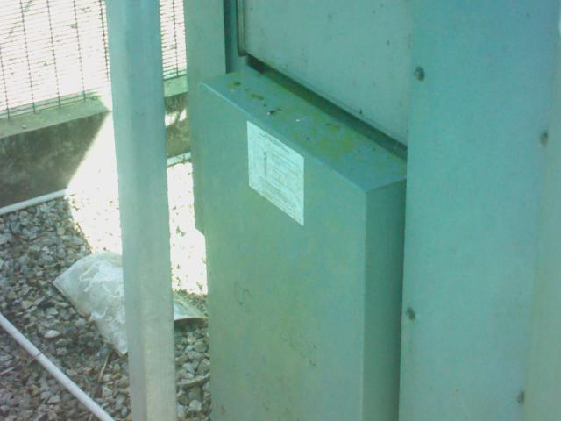
 | PARAMETER |  | VALUE
 | Spot Temp.1 (Sp1) |  | 31.6 °C |  |  |  |  |  |  |  |  |  |  |  | PARAMETER |  |  | VALUE
 | Spot Temp. 2 (Sp2) |  | 31.6 °C |  |  |  |  |  |  |  |  |  |  |  | Serial No. |  |  | {{ panel.serialnumber }}
 | Average Temp. (Ar1) |  | 31.8 °C |  |  |  |  |  |  |  |  |  |  |  | Heater (A) |  |  | -
 | Ambient Temp. |  | 23.2 °C |  |  |  |  |  |  |  |  |  |  |  | CB Position |  |  | CLOSE
 | Delta T ( ∆ T) |  | 0.0 °C |  |  |  |  |  |  |  |  |  |  |  | Busbar Position |  |  | -
 | Load (A) |  | - |  |  |  |  |  |  |  |  |  |  |  | Cable Type |  |  | XLPE
 | Defect
 | ULTRASOUND IMAGE
 | 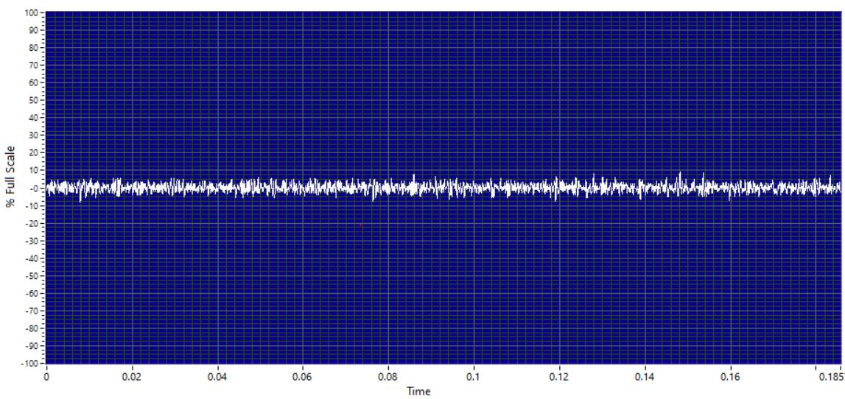
 | Decibel (dB) |  |  | (( panel.db_level }}
 | Sound characteristic |  |  | {{ panel.us.char }}
 | Severity
 | Sound clip |  |  | 
Analysis & Recommendations:
Analysis: No Anomaly.
Recommendation: -

